2024

V3.0

The London policing College

1/1/2024

**London Policing College Data Protection Policy**

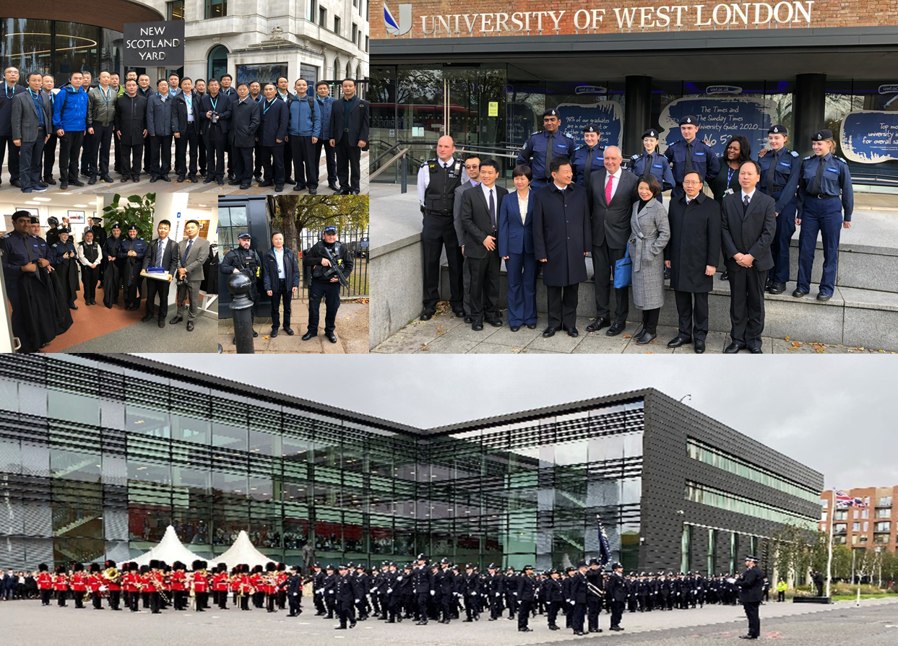

Contents

Introduction 1

Scope 1

Data protection principles 1

Process/procedures/guidance 2

Data Subject Rights 3

Special category personal data 4

Responsibility for the processing of personal data 4

Monitoring and review 5

# Introduction

The London Policing College provides training and consultancy assistance to its clients.

The personal data that London Policing College processes to provide these services relates to its clients and other individuals as necessary, including staff and suppliers’ staff is governed by legislation.

This policy sets out London Policing College’s commitment to ensuring that any personal data, including special category personal data, which London Policing College processes, is carried out in compliance with data protection law. London Policing College processes the personal data of staff from all over the world, including the personal data of a large number of non-EU citizens, but is committed to ensuring that all the personal data that it processes is done in accordance with data protection law. London Policing College ensures that good data protection practice is imbedded in the culture of our staff and our organisation.

London Policing College’s other data protection policies and procedures are (these should be considered and may not all be necessary):

* record of processing activities
* privacy notices (website, clients, employees)
* personal data breach reporting process and a breach register
* data retention policy
* data subject rights procedure
* data protection impact assessment process
* IT security policies

‘Data Protection Law’ includes the General Data Protection Regulation 2016/679; the UK Data Protection Act 2018 and all relevant EU and UK data protection legislation.

# Scope

This policy applies to all personal data processed by London Policing College and is part of London Policing College’s approach to compliance with data protection law. All London Policing College staff are expected to comply with this policy and failure to comply may lead to disciplinary action for misconduct, including dismissal.

# Data protection principles

London Policing College complies with the data protection principles set out below. When processing personal data, it ensures that:

* it is processed lawfully, fairly and in a transparent manner in relation to the data subject (‘lawfulness, fairness and transparency’)
* it is collected for specified, explicit and legitimate purposes and not further processed in a manner that is incompatible with those purposes (‘purpose limitation’)
* it is all adequate, relevant and limited to what is necessary in relation to the purposes for which they are processed (‘data minimisation’)
* it is all accurate and, where necessary, kept up to date and that reasonable steps will be taken to ensure that personal data that are inaccurate, having regard to the purposes for which they are processed, are erased or rectified without delay (‘accuracy’)
* it is kept in a form which permits identification of data subjects for no longer than is necessary for the purposes for which the personal data are processed (‘storage limitation’)
* it is processed in a manner that ensures appropriate security of the personal data, including protection against unauthorised or unlawful processing and against accidental loss, destruction or damage, using appropriate technical or organisational measures (‘integrity and confidentiality’)

London Policing College will facilitate any request from a data subject who wishes to exercise their rights under data protection law as appropriate, always communicating in a concise, transparent, intelligible and easily accessible form and without undue delay.

# Process/procedures/guidance

London Policing College will:

* ensure that the legal basis for processing personal data is identified in advance and that all processing complies with the law
* not do anything with your data that you would not expect given the content of this policy and the fair processing or privacy notice
* ensure that appropriate privacy notices are in place advising staff and others how and why their data is being processed, and, in particular, advising data subjects of their rights
* only collect and process the personal data that it needs for purposes it has identified in advance
* ensure that, as far as possible, the personal data it holds is accurate, or a system is in place for ensuring that it is kept up to date as far as possible
* only hold onto your personal data for as long as it is needed, after which time London Policing College will securely erase or delete the personal data – London Policing College’s data retention policy sets out the appropriate period of time
* ensure that appropriate security measures are in place to ensure that personal data can only be accessed by those who need to access it and that it is held and transferred securely

London Policing College will ensure that all staff who handle personal data on its behalf are aware of their responsibilities under this policy and other relevant data protection and information security policies, and that they are adequately trained and supervised.

Breaching this policy may result in disciplinary action for misconduct, including dismissal. Obtaining (including accessing) or disclosing personal data in breach of London Policing College ’s data protection policies may also be a criminal offence.

# Data Subject Rights

London Policing College has processes in place to ensure that it can facilitate any request made by an individual to exercise their rights under data protection law. All staff have received training and are aware of the rights of data subjects. Staff can identify such a request and know who to send it to.

All requests will be considered without undue delay and within one month of receipt as far as possible.

**Subject access**: the right to request information about how personal data is being processed, including whether personal data is being processed and the right to be allowed access to that data and to be provided with a copy of that data along with the right to obtain the following information:

* the purpose of the processing
* the categories of personal data
* the recipients to whom data has been disclosed or which will be disclosed
* the retention period
* the right to lodge a complaint with the Information Commissioner’s Office
* the source of the information if not collected direct from the subject, and
* the existence of any automated decision making

**Rectification**: the right to allow a data subject to rectify inaccurate personal data concerning them.

**Erasure**: the right to have data erased and to have confirmation of erasure, but only where:

* the data is no longer necessary in relation to the purpose for which it was collected, or
* where consent is withdrawn, or
* where there is no legal basis for the processing, or
* there is a legal obligation to delete data

**Restriction of processing**: the right to ask for certain processing to be restricted in the following circumstances:

* if the accuracy of the personal data is being contested, or
* if our processing is unlawful but the data subject does not want it erased, or
* if the data is no longer needed for the purpose of the processing but it is required by the data subject for the establishment, exercise or defence of legal claims, or
* if the data subject has objected to the processing, pending verification of that objection

**Data portability**: the right to receive a copy of personal data which has been provided by the data subject and which is processed by automated means in a format which will allow the individual to transfer the data to another data controller. This would only apply if London Policing College was processing the data using consent or on the basis of a contract.

**Object to processing**: the right to object to the processing of personal data relying on the legitimate interests processing condition unless London Policing College can demonstrate compelling legitimate grounds for the processing which override the interests of the data subject or for the establishment, exercise or defence of legal claims.

# Special category personal data

This includes the following personal data revealing:

* racial or ethnic origin
* political opinions
* religious or philosophical beliefs
* trade union membership
* the processing of genetic data, biometric data for the purpose of uniquely identifying a natural person
* an individual’s health
* a natural person's sex life or sexual orientation
* criminal convictions or offences

London Policing College processes special category data of clients and third parties as is necessary to provide legal services for the establishment, exercise or defence of legal claims.

London Policing College processes special category data of employees as is necessary to comply with employment and social security law. This policy sets out the safeguards we believe are appropriate to ensure that we comply with the data protection principles set out above London Policing College also has a data retention policy which sets out how long special category data will be held onto.

# Responsibility for the processing of personal data

The partners of London Policing College take ultimate responsibility for data protection.

If you have any concerns or wish to exercise any of your rights under the GDPR, then you can contact the data protection lead in the following ways:

Name Chief Information Officer  
Address London Policing College,46 -54 High Street, Ingatestone, Essex CM4 9DW  
Email Admin@lonpolcol.co.uk

# Monitoring and review

This policy was last updated on 17th February 2020 and shall be regularly monitored and reviewed, at least every two years.